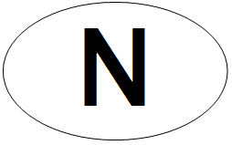 |  | 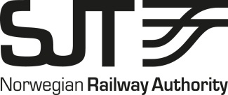
Form for registration of authorised vehicles
in conformity with Directive 2008/57/EC and applicable national legislation
Application for: New registration ☐ Modification ☐ Withdrawal ☐
INFORMATION ABOUT THE VEHICLE
1. Number
1.1. European Vehicle Number
1.2. Number previously assigned to the vehicle:
2. EEA state where the registration is sought and NSA that authorised the vehicle
2.1. EEA state: Norway
2.2. Name of NSA: Norwegian Railway Authority
3. Manufacturing year:
4. EC reference
4.1. Date of declaration:
4.2. EC reference:
4.3. Name of issuing body:
4.4. Registered business number:
Address of organisation
4.5. Street and number:
4.6. Town:
4.7. Country code: 4.8. Post code:
5. Reference to the European register of authorised types of vehicles:
5bis. Series:
6. Restrictions
6.1. Restrictions (code):
6.2. Restrictions (text):

INFORMATION ABOUT THE ENTITIES RESPONSIBLE FOR THE VEHICLE
7. Owner
7.1. Name of organisation:
7.2. Registered business number:
Address of organisation
7.3. Street and number:
7.4. Town:
7.5. Country code: 7.6. Post code:
8. Keeper
8.1. Name of organisation:
8.2. Registered business number:
Address of organisation
8.3. Street and number:
8.4. Town:
8.5. Country code: 8.6. Post code:
8.7. Vehicle Keeper Marking (VKM):
OPERATIONAL INFORMATION
9. Entity in charge of maintenance
9.1. Name of organisation:
9.2. Registered business number:
Address of organisation
9.3. Street and number:
9.4. Town:
9.5. Country code: 9.6. Post code:
9.7. E-mail address:
10. Withdrawal
10.1. Mode (code):
10.2. Date:
11. EEA states where the vehicle is already authorised:
IDENTIFICATION OF THE ENTITY APPLYING FOR REGISTRATION:
Date: Name and signature of responsible officer:

Not applicable for first registration.

